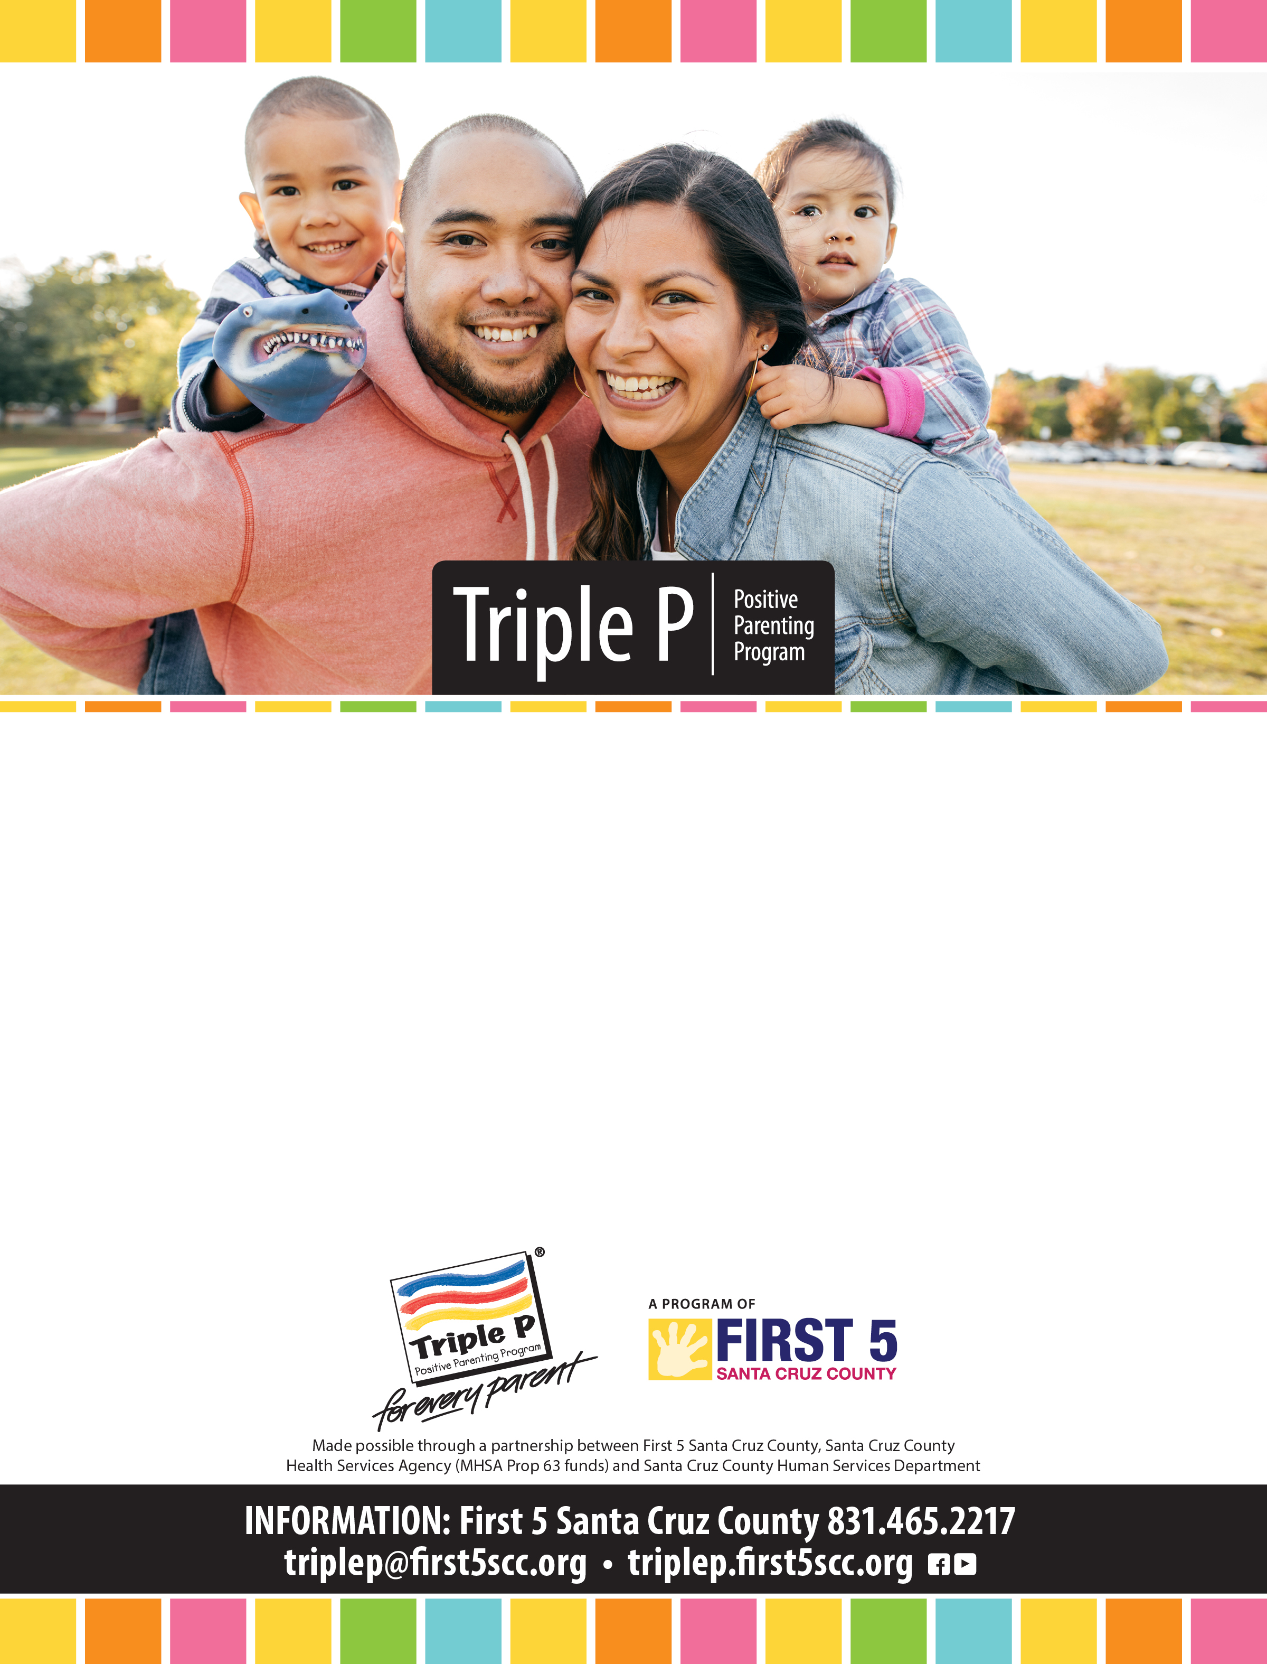

# **January is Positive Parenting Awareness Month!**

Got kids? Triple P classes and one-on-one meetings offer tools   
to strengthen your relationship with your child or teen.

Triple P is a scientifically proven, world-renowned positive   
parenting program available to all families in Santa Cruz County.

Find a Triple P class or practitioner:

**Triplep.first5scc.org**